**Assignment -4**

Python Programming

|  |  |
| --- | --- |
| Assignment Date | 18-10-2022 |
| Student Name | SOWMIYA M |
| Student Roll Number | 111719106148 |

**Question 1:**

**Import the necessary libraries** Solution:

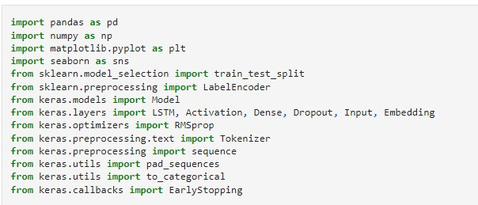

**Question 2:**

**Download the Dataset** Solution:

Dataset Downloaded and uploaded to drive [https://www.kaggle.com/code/kredy10/simple-lstm-for-textclassification/data](https://www.kaggle.com/code/kredy10/simple-lstm-for-text-classification/data)

**Question 3:**

**Read dataset and do pre-processing** Solution:

Read dataset

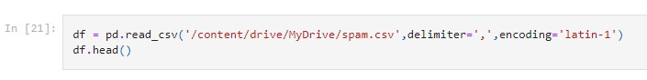

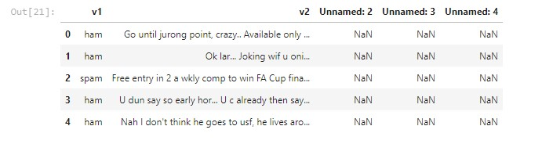

Pre-processing the Dataset

